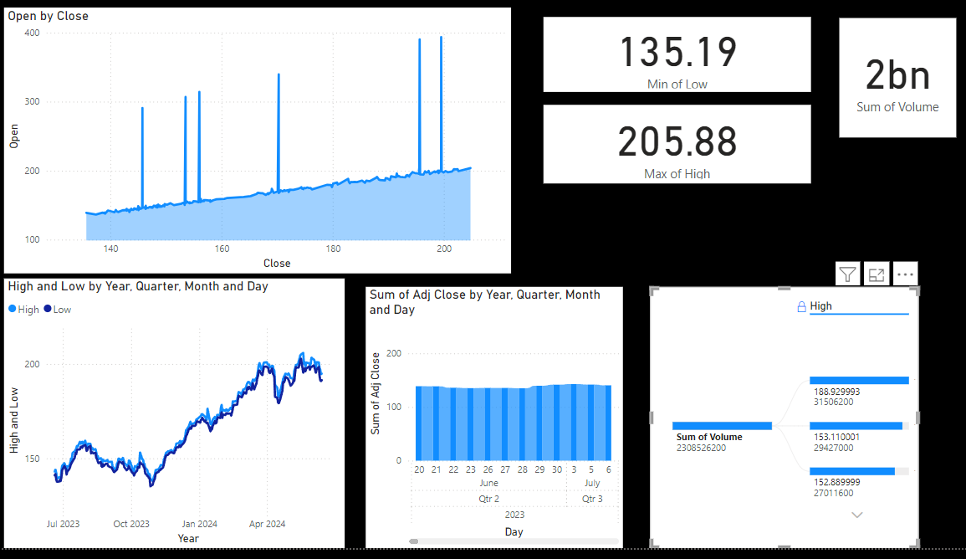

**CREATED A POWERBI DASHBOARD FOR JPM COMPANY FINANCIAL DATA FROM YAHOOFINACE**

**1. Market Data and News**

**Real-Time Market Data:** Yahoo Finance provides real-time stock quotes, financial news, and market data. This includes information on major stock indices like the S&P 500, NASDAQ, and Dow Jones

**This tells which market that the company belong to**

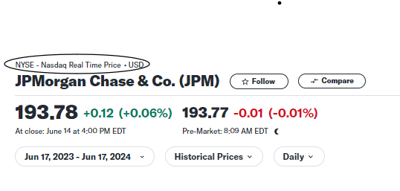

**Financial News**: The platform aggregates news from various sources, offering insights into market trends, economic developments, and company-specific news that can impact stock prices.

**2. Stock Analysis Tools**

**Charts and Graphs:** Users can access interactive charts and graphs to analyze stock performance over different time frames. These visual tools help in understanding trends and making informed investment decisions.

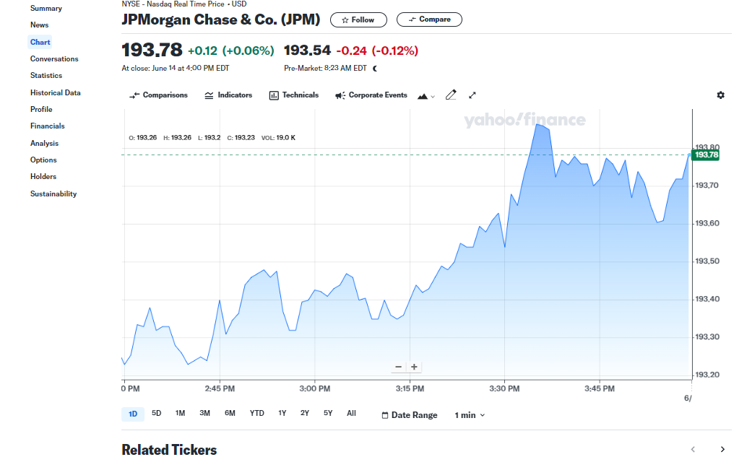

**Technical Indicators**: The platform offers a variety of technical indicators (e.g., moving averages, RSI, MACD) to help investors analyze stock price movements and identify potential buy or sell signals.

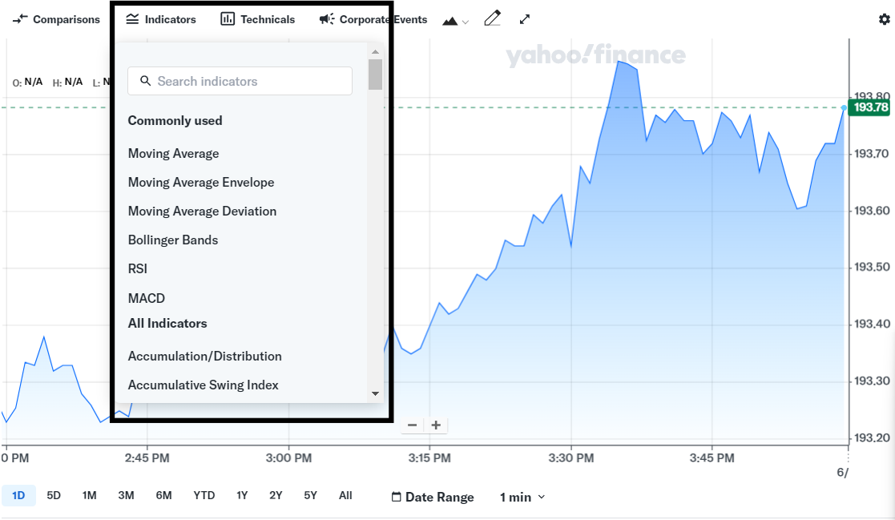

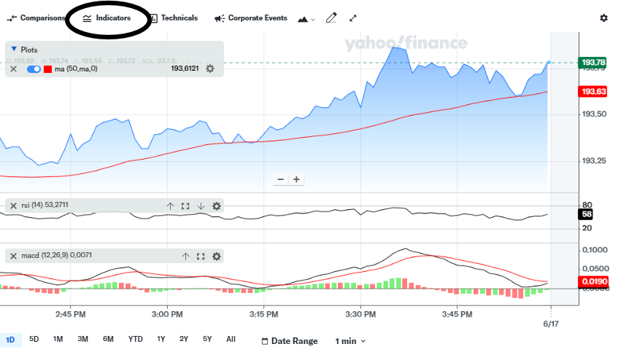

**3. Financial Data**

Company Profiles: Detailed information about publicly traded companies, including financial statements, earnings reports, and key statistics.

**Historical Data:** Access to historical stock prices and performance data, enabling users to perform long-term analyses.

**4. Portfolio Management**

**Watchlists and Portfolios:** Users can create watchlists to monitor stocks of interest and manage their investment portfolios. This feature allows for tracking gains/losses and evaluating portfolio performance.

**Alerts and Notifications:** Customizable alerts for stock price changes, news updates, and other relevant events.

**5. Research and Education**

**Analyst Ratings and Reports:** Access to analyst ratings, price targets, and research reports, providing professional insights and recommendations.

**Educational Resources:** Articles, tutorials, and guides on investing, personal finance, and market analysis. These resources are valuable for both novice and experienced investors looking to expand their knowledge.

**6. Community and Interaction**

**Discussion Forums**: Users can participate in discussion forums and comment sections to share insights, ask questions, and engage with other investors.

**User-Generated Content:** The community-driven aspect allows for sharing strategies, tips, and experiences.

**How Yahoo Finance Helps in Understanding Data and Investing in Stocks**

**Accessibility of Information:** Yahoo Finance centralizes a vast amount of information in one place, making it easier to access and compare data.

**Informed Decision-Making:** The tools and resources available aid in performing thorough analyses, which is crucial for making informed investment decisions.

**Monitoring and Adjustments:** Portfolio management features help investors track their investments and make necessary adjustments based on performance and market conditions.

**Learning and Growth:** The educational content and community interactions provide opportunities for continuous learning and improvement in investment strategies.

By leveraging Yahoo Finance, investors can stay updated on market trends, analyze stock performance, manage their portfolios, and educate themselves on various aspects of investing. This comprehensive approach is instrumental in developing a deeper understanding of the financial markets and making sound investment decisions.

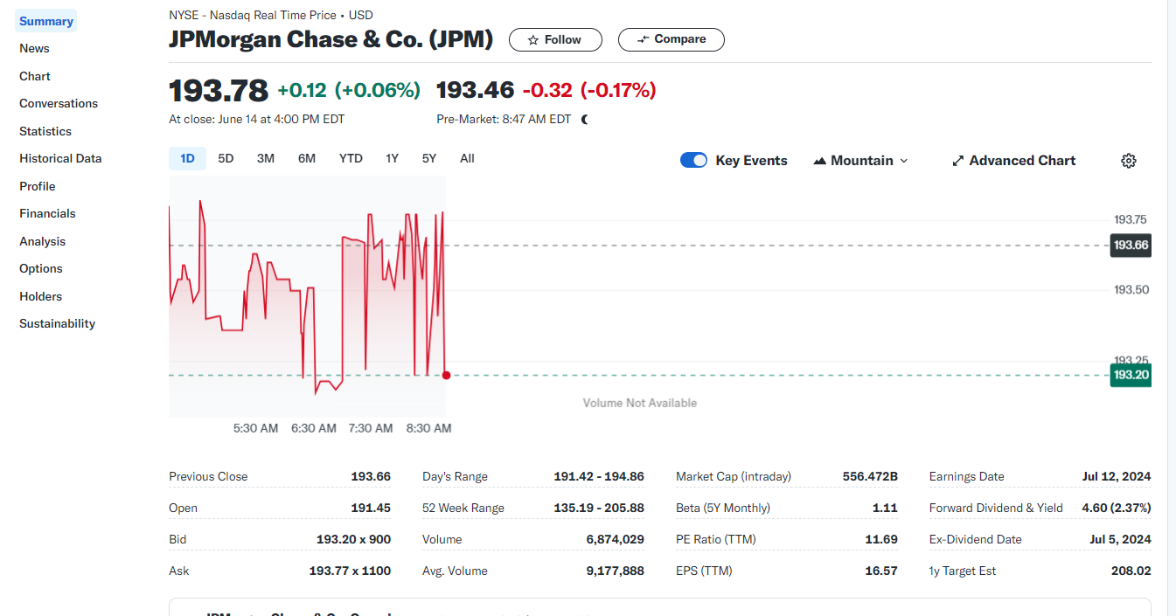

INTERPRETATION

Take a symbol-JPM

Stock market that jpm is located is NYSE-(currency)US dollars

193.78-current price of the stock

+indicates the value increase in the price of stock and also the percentage rate

-indicates the value decreases in the price of stock and also the percentage rate

Previous close- it’s the price that was there before day when the stock was opened

Open – it is the price at which the stock was open today

Day’s range – it shows the lowest price and the highest price at which the stock is being traded

52-week range – it shows the lowest and the highest price at which the stock is traded in a year

Volume – no of shares brought and sold by the company today

PE- PRICE TO EARNING RATIO (the less is the better)

EPS-EARNING PER SHARE (the more is the better)

Forward dividend and yield- how much the company paid in dividend last time

1-year target estimated – its is an estimated number that a company can grow in future given by analysists